Flipped Learning Design

Definition

Flipped learning design is a blended approach in which learning occurs both inside and outside the classroom. Learners establish their conceptual knowledge by watching videos and reading books or web-based or other resources on a particular topic in their own time outside the classroom and demonstrate their gained knowledge through hands-on experience in the form of problem-solving scenarios in class.

In computing education
In computing, practical knowledge is equally essential as conceptual knowledge because it leads a person to a deeper understanding of the concepts. The flipped learning approach enhances learning by providing students with equal opportunity for both firsthand practical experience and conceptual knowledge.

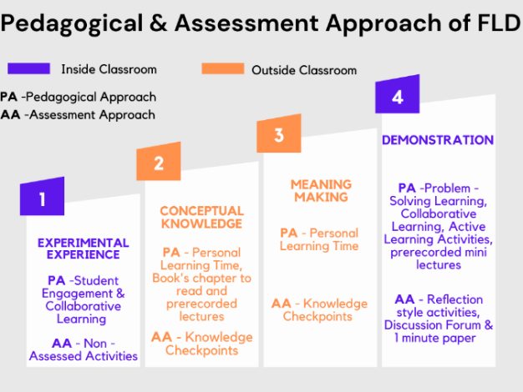
Pedagogical approaches
- Enhance student engagement through creative and interactive activities, experiments, and games.
- Use problem-solving based activities to establish the connection between theoretical knowledge and designed tasks.
- Create a personalized learning environment by allowing each learner to learn at their own pace.
- Encourage collaborative learning by providing learners with various opportunities to work in teams and interact with their peers and the instructor.
- Provide learners with an opportunity to reflect on the knowledge they have gained.

Assessment approaches
- Assess reflection-style activities, e.g., discussion forums and 1-minute written reflections to evaluate the student’s understanding of concepts.
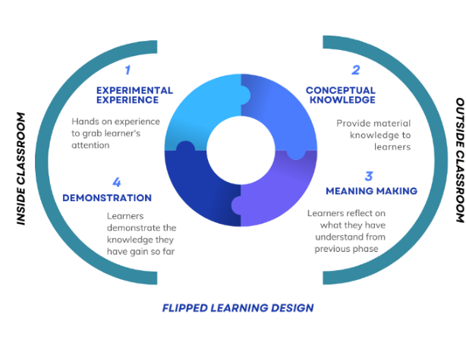
- Conduct knowledge checkpoints like quizzes and discussion questions on student learning. In addition to providing individual assessment, when many students have gaps in the same area, the instructor can add mini-lectures or additional in-class activities.
- Observe student reactions in the application stage by the participation in the designed activities.

Theoretical perspective
In flipped learning design, the standard learning approach is modified and divided into two main components. First, students are provided with reading materials, videos, or other resources to review outside the classroom at their own time. Secondly, students apply their learning in live problem-solving scenarios in the presence of instructor. Students became active learners in the flipped learning approach (Davies et al., 2013). Flipped learning encourages critical thinking and creative approaches in the classroom (Howell, 2021).

Step 1 – Experimental Experience
The learner experiences pilot activities prior to reading any content. This usually is a hands-on experience that helps the learner fully engage with the content. This step is essential to grab the learner’s attention. Implementing pedagogical approaches like student engagement with the course in the form of activities, games, and experiments is encouraged. Collaborative learning is essential for this step as it allows students to discuss with their peers. These activities should be non-assessed activities. Teamwork is encouraged.

Course Introduction
Prof. Myntra wants to introduce the flipped learning design in her Introductory Programming course. She begins by providing a brief introduction to how this class might be different from the traditional classroom. Students are encouraged to form a group prior to starting the activity.

Experimental Experience
Later, Prof. Myntra instructs students to run a test case on the provided C program. As students begin the activity, they initiate discussion within their teams and do an internet search on the online coding communities such as GitHub, Stack Overflow and GitLab to find the best types of test cases to test the code. This engages the students in group discussion and in selecting the best possible solution for their problems. It also helps them begin to develop curiosity about the course content.

Learning setting
The experimental experience is conducted inside the classroom in the presence of the instructor or knowledge assistant.

Step 2 – Conceptual Knowledge
After students have gained an initial experience of the course content, materials created by experts are provided. This may include videos and presentations to watch and books and online websites to read to gather experts' opinions on this course content. Content can be created by the instructor or existing content can be selected by the instructor. Self-paced interactive content can also be used.

Engage With the Content
In the next phase, Prof. Myntra provides a link to an interactive website that summarizes the types of test cases, as well as a book chapter with more detail on each type. Prof. Myntra might also create mini-lectures (prerecorded audio or video files) on the content. Students are encouraged to go through the material before coming to class the next day. Material is available to students from the beginning of the semester, and are prompted to read the materials in the week leading up to the next in-person meeting.

Learning Setting
Students will review content outside the classroom. In this personalized learning environment, students will engage with the information at their own pace and in their preferred manner.

Step 3 – Meaning Making
Students establish a connection between their experiences in the first step and what they understood during the second step. In these knowledge checkpoints, students will be encouraged to provide reflective content in the form of audio, videos, or question/answer format. The instructor will utilize these as formative assessments of individual student learning, as well as determining whether any material will need to be addressed in person if many students have gaps in particular areas. This will also aid in changes or additions to the material for next year.

Knowledge Checks

Students will complete online quizzes including multiple-choice questions spread throughout their readings. This will test their basic understanding of the material. The system will automatically generate formative feedback on correct or incorrect answers.

Then, students will participate in a 1-prompt reflection. The prompt might include a small case description and includes questions such as “what test case would you have used in the first experimental scenario, and why?” This deep reflection format assists students’ metacognitive experience during learning .

Learning Setting
Students should be allowed to reflect deeply and construct the explanation of the content provided to them in their own time.

Step 4 – Demonstration
In this step, students demonstrate their understanding of the concept and apply the knowledge in problem-solving scenarios. Utilizing the knowledge that they gained, students will use the materials to solve the problem in a way that will make sense to them. Students are asked to write a 1-minute reflective paper to assess their learning. In a large class setting, it would be encouraged to instruct students to put their solutions in online discussion forums for others to see in the classroom and give a short presentation to the class. Also, in this step students can be asked to provide a reflection on their in-class learning experience, what they like, what they struggle with and any suggestions for improvement next time. The instructor can guide and provide more information on students’ concerns. Also, their peers can provide feedback whenever required.

Adjust to Meet Students’ Needs
The Knowledge Check quizzes, and reflection statements students submitted in Step 3 indicated that many students did not understand the concept of Test cases used in C programming well. Prof. Myntra gives a 10-minute mini-lecture on this topic, checking in to ensure all students now understand the concept.

Active Learning Activities
Students are asked to test the new code provided by Prof. Myntra in the project Test Case Generation. Prof. Myntra will clearly define the test case requirements. Students will be encouraged to maintain test case design and documentation for execution and analysis. Additionally, students will be required to write bug reports as an introduction to the new topic.

Final Reflection

Students are required to write a 1-page reflection paper as an assignment about what they have learned in the class.

Learning Setting
Students should demonstrate their knowledge inside the classroom. Instructors should encourage the students to work in teams in this step.

Reference
Davies, R., Dean, D., Ball, N. (2013). Flipping the classroom and instructional technology integration in a college-level information systems spreadsheet course. Educational Technology Research & Development, 61 (4) (2013), pp. 563-580.
Howell, R. (2021). Engaging students in education for sustainable development: The benefits of active learning, reflective practices and flipped classroom pedagogies. Journal of Cleaner Production, 325, 129318.

